**Travel Desi**

**[Ticket Booking Solution]**

**Contents:**

1. Summary
2. ER Diagram
3. Schema Diagram

**Team Composition:**

Mohammed Afnan Althaf Samad

Ali M Rizwi

**Entity Sets:**

The ER diagram of our projects possess eight entity sets which are as follows:

1. Account Login

This entity has the login data of all the users who have an account in the system, users the login using their AccountName and Password.

1. User

This entity set has all the user details and their attributes like UserID, UserName, UserAddress etc.

1. Search

This entity has the data which allows the user to find their desired transport according to Date, SeatType etc.

1. BookingDetails

This entity has the data of the users search choice.

1. Payment

This entity deals with data regarding the payment process of the selected booking.

1. Schedule

This entity has the Schedule data related to all the booking the user has made.

1. Passengers

This entity has data of all the passengers for whom the booking was done, like PassengerName, PassengerEmail, PassengerAge etc.

1. TransportDetails

This entity has data of the transport vehicle like VehicleID, VehicleNumberPlate etc

**Relations:**

The ER diagram includes 9 relations, which are as follows:

1. Executes
2. Searches
3. Fetches
4. Pays
5. Decides
6. Requires
7. Manages
8. Possess
9. Includes

**ER Diagram:**

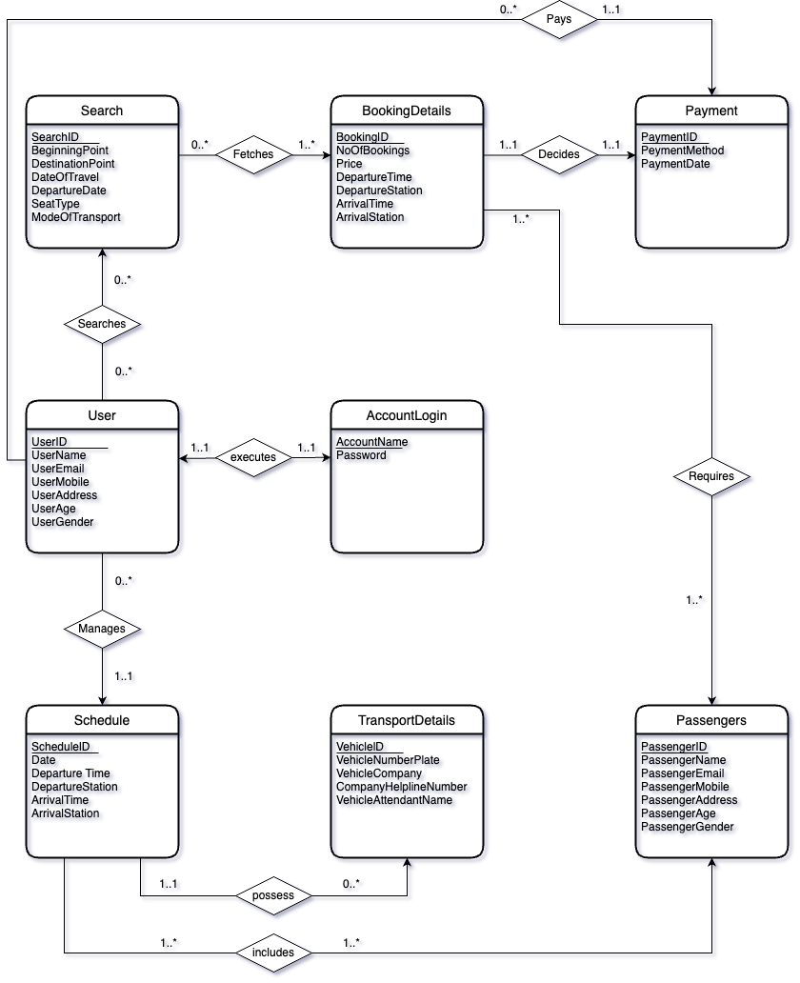

**Schema Diagram:**

